**Activity: Installing custom visualizations from AppSource**

**Introduction**

Microsoft Power BI contains a large selection of core visualizations but in your role as a data analyst, you may need to expand this choice by using custom visualizations.  Custom visualizations play a significant role in enhancing the capabilities and impact of Power BI reports and dashboards. With them, you can create bespoke and personalized visuals for your organization that address specific business requirements of the organization. This helps you to create reports that are more accurate and that have a greater impact on decision-makers.

You have already explored how to add custom visualizations using Python. Another important source of custom visuals is the Microsoft marketplace AppSource.

**AppSource Visuals**

AppSource offers a diverse collection of custom visualizations created by third-party developers and designers.  By downloading these and integrating them into Power BI, analysts can expand the choice of visualization options beyond Power BI’s core options. All the visuals in AppSource are tested and approved by Microsoft for functionality and quality.

**Scenario**

As a member of the Adventure Works data analytics team, you are helping to create Power BI reports and dashboards showing regional sales results and trends. You feel that some of the data collected would not be displayed to the best effect if you use only the Power BI core visualizations. You decide to explore the choice of visualizations offered in AppSource to find a more appropriate visual. Let’s look at how you can import a custom visual from AppSource and how it can be used and formatted in your Power BI report.

**Step 1: Import the visual**

1. Download the report *Adventure Works Regional Sales.pbix* and open it in Power BI desktop.

[Adventure Works Regional Sales](https://d3c33hcgiwev3.cloudfront.net/ITnAoT3wQUCRjDZ_Sv6PzA_5eff423238d34d1faee9c78a8c29cae1_Adventure-Works-Regional-Sales-C6M2L3-Item-02.pbix?Expires=1712275200&Signature=ieN~Laq5~M-Ao9mpvEJ3JZNT1j-VahYbkUT72lH1krqhefEPyWX4j2jlSH81vHoYL5TCJBi-xM7FpyCOp2-DG0f6ftgivlPCkHATMZFpOd9Hts5psAoa3aEJk8ZSEOST7HpvkjzBw6iLbf7FsYPiQgAwiQN6a6NU8wEv4vK8D64_&Key-Pair-Id=APKAJLTNE6QMUY6HBC5A" \t "_blank)

[PBIX File](https://d3c33hcgiwev3.cloudfront.net/ITnAoT3wQUCRjDZ_Sv6PzA_5eff423238d34d1faee9c78a8c29cae1_Adventure-Works-Regional-Sales-C6M2L3-Item-02.pbix?Expires=1712275200&Signature=ieN~Laq5~M-Ao9mpvEJ3JZNT1j-VahYbkUT72lH1krqhefEPyWX4j2jlSH81vHoYL5TCJBi-xM7FpyCOp2-DG0f6ftgivlPCkHATMZFpOd9Hts5psAoa3aEJk8ZSEOST7HpvkjzBw6iLbf7FsYPiQgAwiQN6a6NU8wEv4vK8D64_&Key-Pair-Id=APKAJLTNE6QMUY6HBC5A" \t "_blank)

2. First, assess the current layout of the report by viewing it in **Report view** in Power BI. The report contains a donut chart which shows sales figures by country and a column chart showing the monthly regional sales.

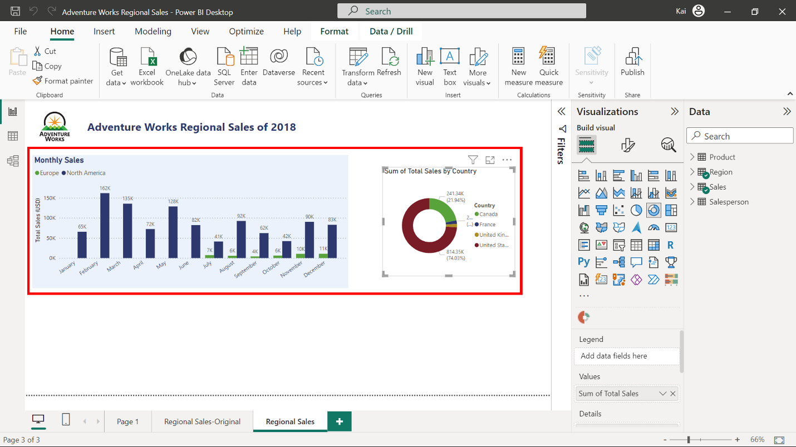

3. Let’s enhance the report by changing the donut chart to an **Aster plot** chart imported from AppSource. An **Aster plot** is a modified **Donut chart** representing the values by the depth of each section.

4. Open the **Visualization pane** and select the ellipses then choose **Get more visuals** from the drop-down. This opens a **Power BI visuals** window.

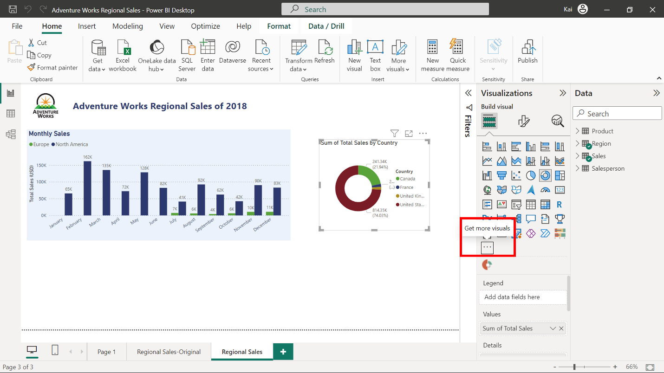

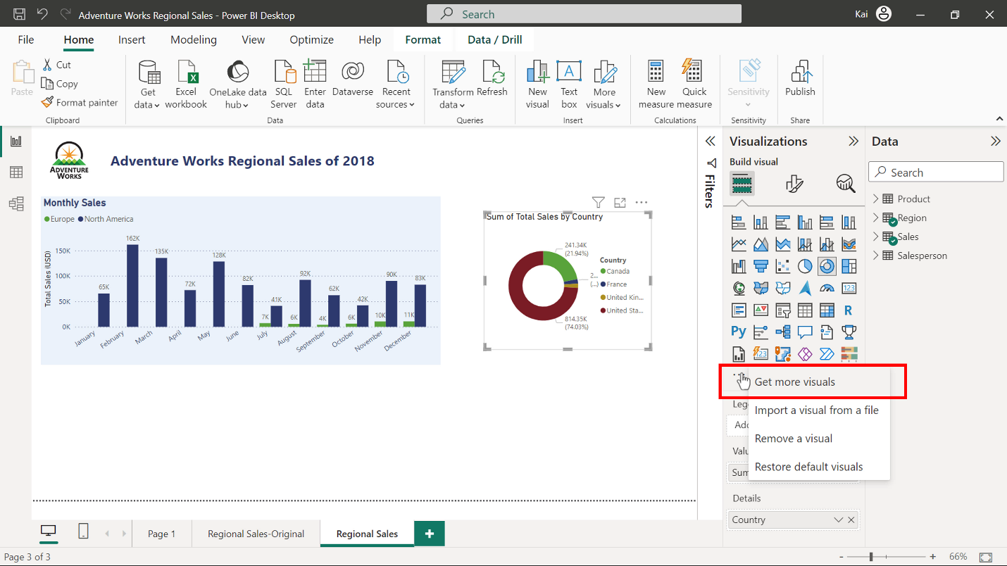

5. The window contains three tabs titled **All visuals**, **Organizational visuals** and **AppSource visuals**. The visuals in AppSource have been tested and approved by Microsoft so the new visual will be downloaded from there. Select the **AppSource visuals** tab.

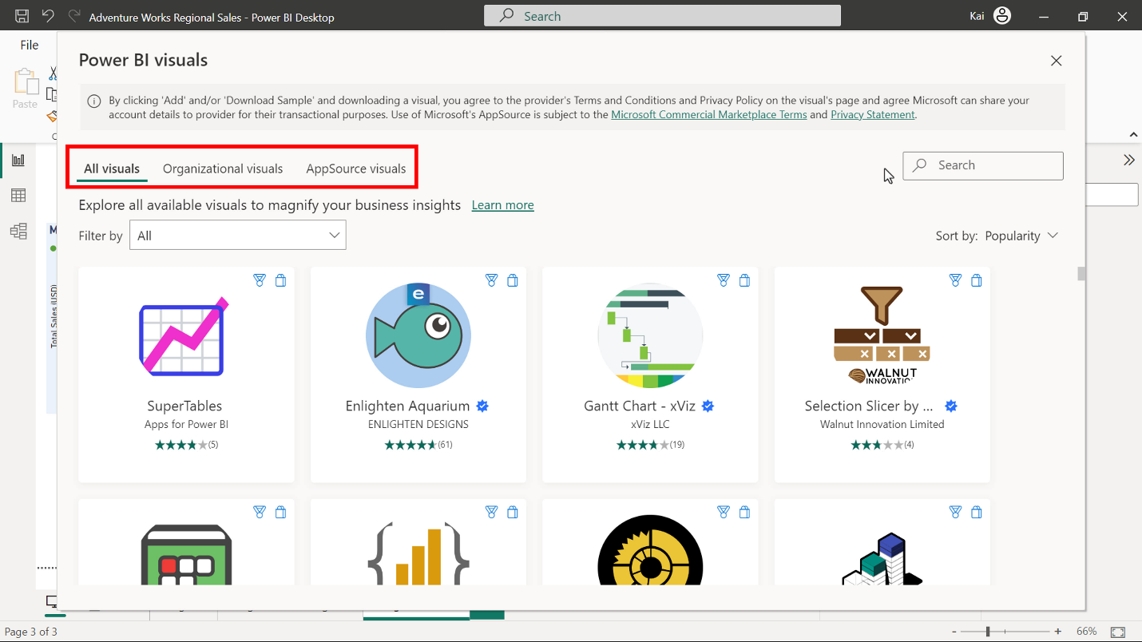

6. In the search bar type **Aster Plot** and when the search results appear select **Aster Plot**. The details page for the Aster Plot visual appears. Select **Add**. This imports the visual and adds it to the **Visualization pane** in Power BI where it can be selected and added to the report.

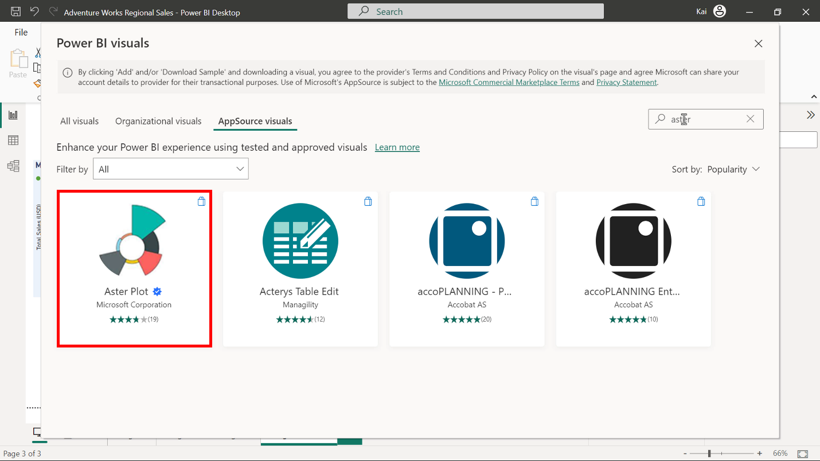

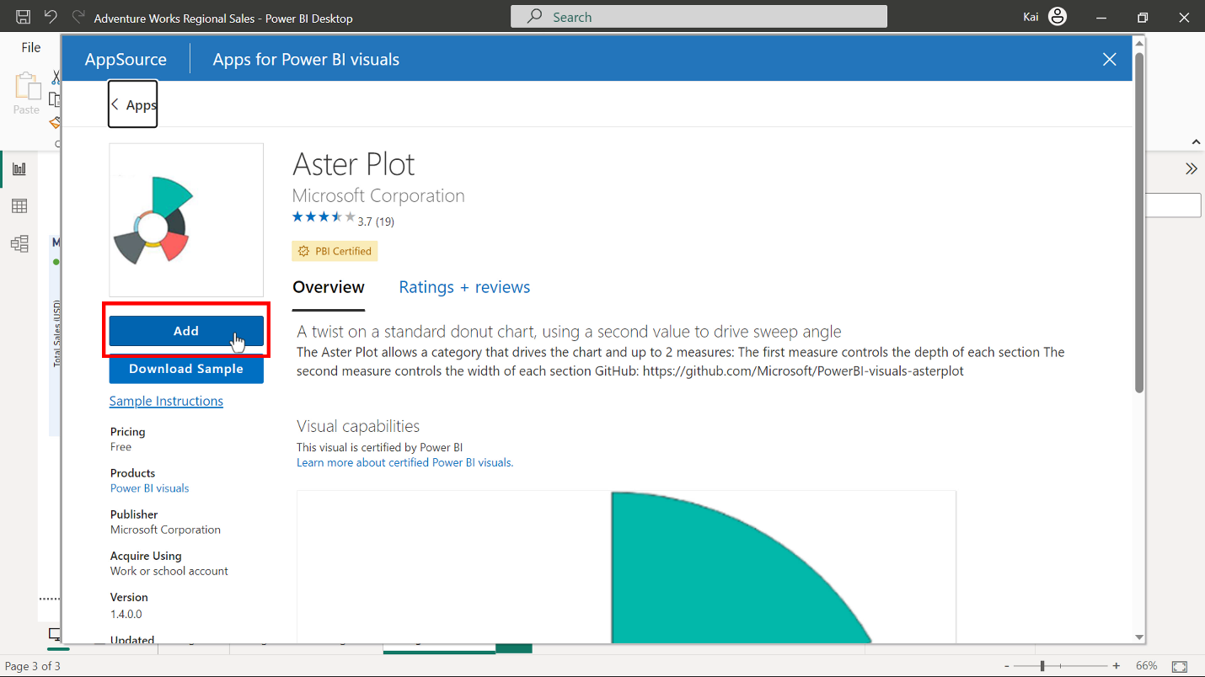

7. Once import is complete, a dialog box appears on screen showing the message **Import successful.** The Astor Plot visual is now a choice in under the **Visualization pane**.  Right click on it and select the **pin to visualization pane** option. This adds the imported visual to the main **Visualization pane** for future use.

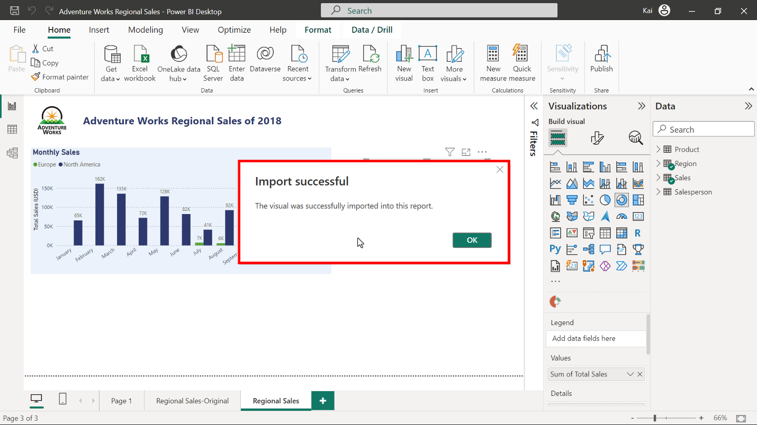

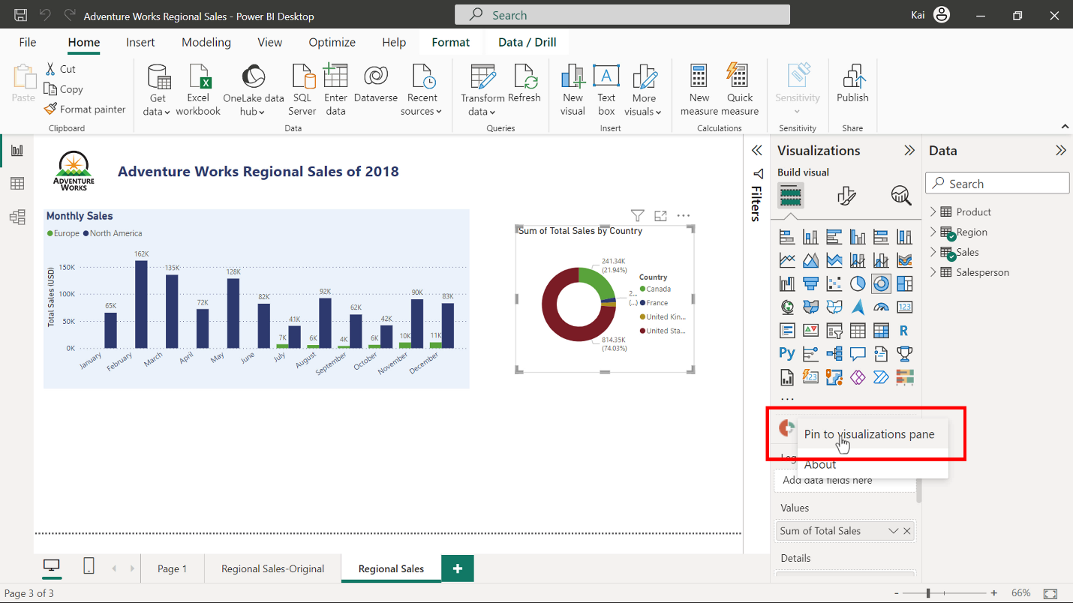

**Step 2: Use and format visual in your report**

1. Select the donut chart, which represents the sales by country figures, and then select the **Astor plot** icon. The **Sales by county** visualization instantly changes from **Donut chart** to **Aster plot** and it can now be formatted to meet the design and analytical requirements.

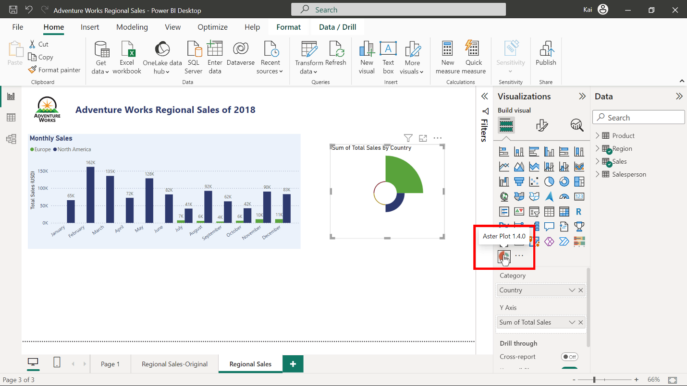

2. Select the **Astor plot** visual. In the **Visualization pane** select the **Format Visual** tab and then  **Visual.** In the **Legend** section make the following series of choices. Turn on the **Legend** by moving the toggle button to the on position. Change the **Legend** position to the left Switch off the **Legend** title by moving the toggle to the off position. Change the color to blue to match the color palette used in the report.

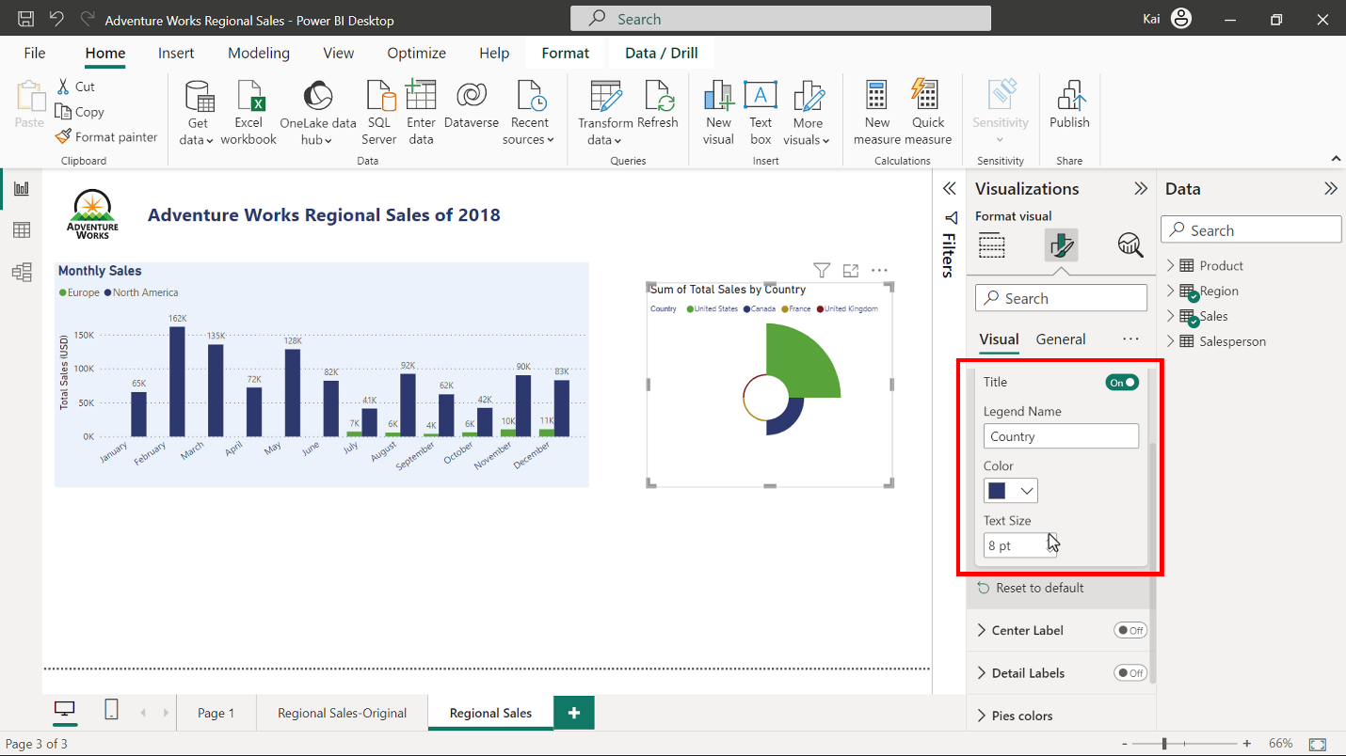

3. In the **Center label section**, **Center label,** toggle the button to the on position, change the color to blue to match with the entire report.

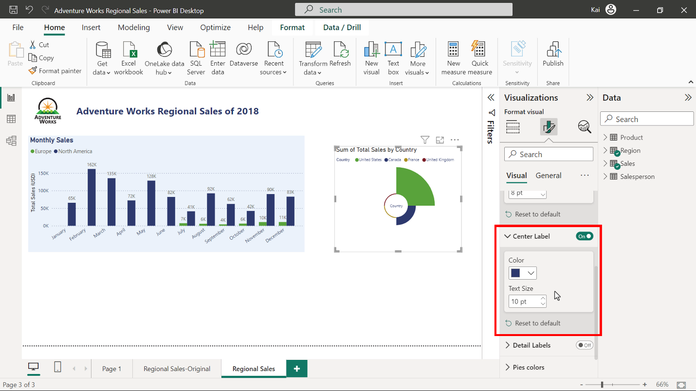

4. In the **Detail labels** section toggle the button to the on position.  Enter 2 in the **Decimal places** section, and again change the color to blue.

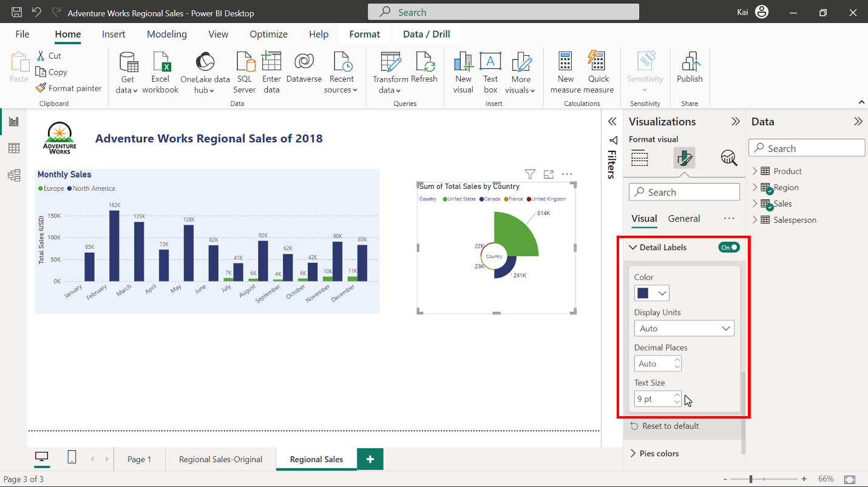

5. Keep the **Pies color** default settings because these are consistent with the report theme.



6. Now change the title of the visual to Sales by Country and format the text to match the settings already used in the report. For this, Go to **Visualization > Format Visual > General > Title.** Change and format the title text.

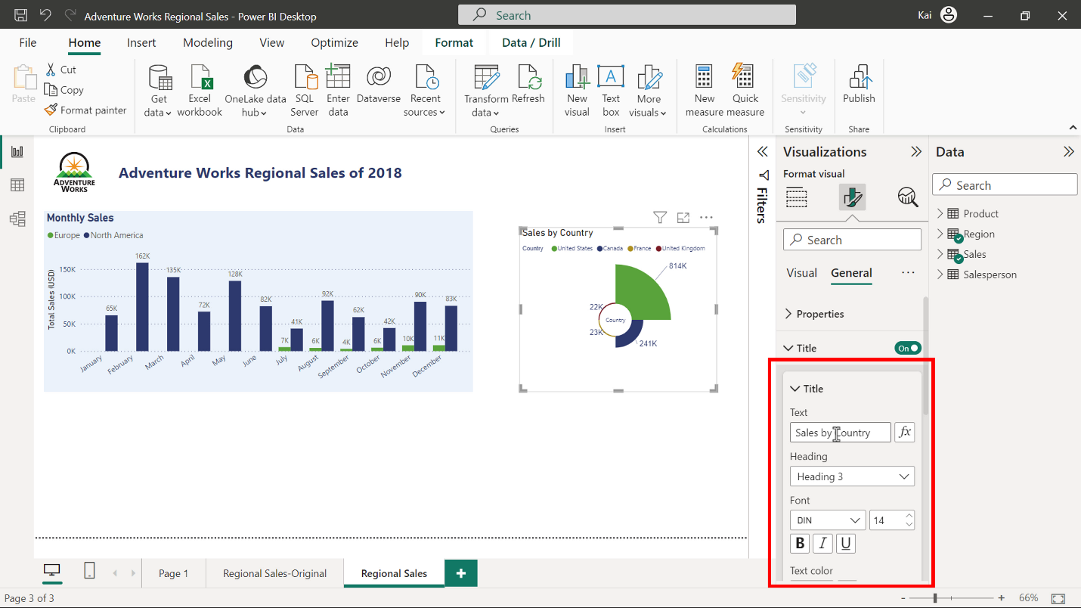

7. As the column chart has a light blue background, so you need to make the report cohesive. Go to **Visualization > Format Visual > General > Effects > Background**. Change the color to light blue and set the transparency value at 70%.

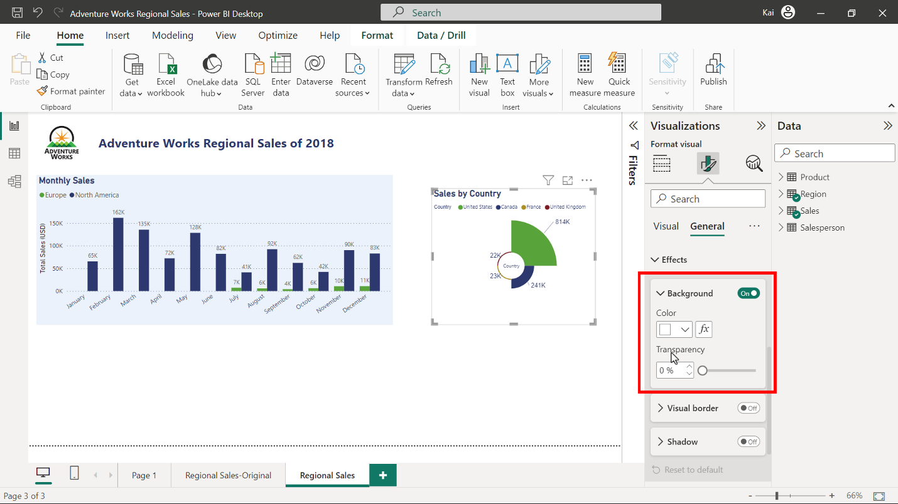

8. Finally, drag the visual to adjust its position in the report and enlarge it so that the entire report looks like a unified design.

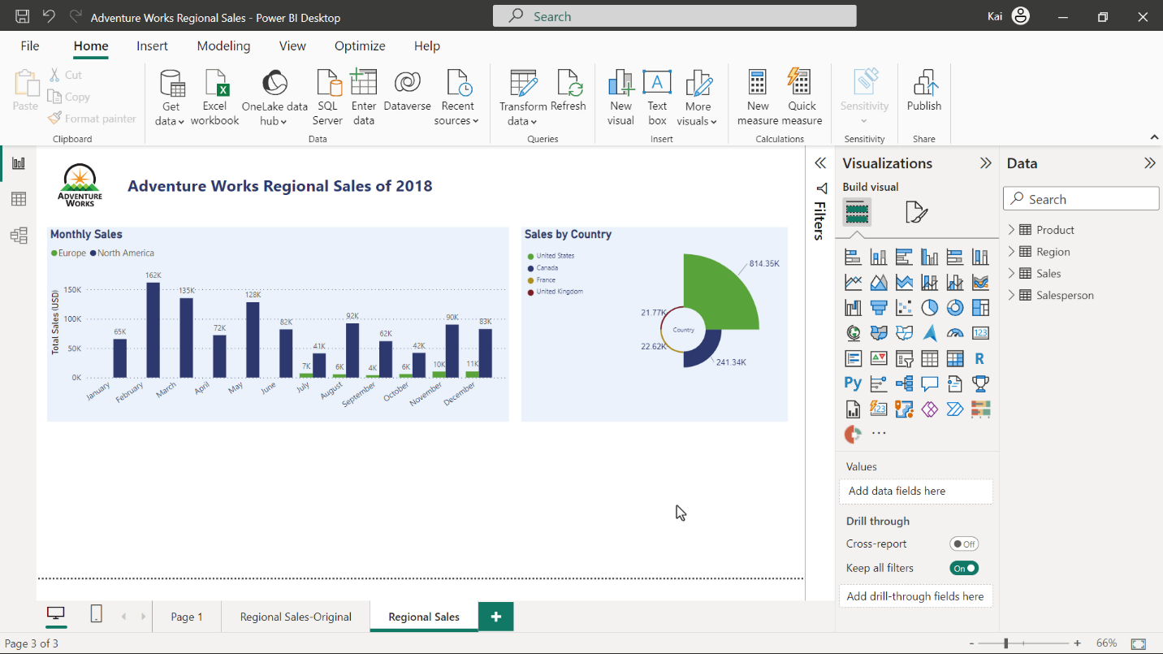

**Conclusion**

AppSource visuals are a valuable resource for creating custom visualizations to address specific needs of businesses. They also enhance data presentation and contribute to the overall effectiveness of Power BI as a business information tool. Moreover, the visuals available in AppSource are tested and validated for their functionality and quality for creating reports and dashboards in Power BI.